NAME: P. Rajakeerthana

# ROLL NUMBER: 2210030240

CO1

1. DEMONSTRATE 5 different tables in html

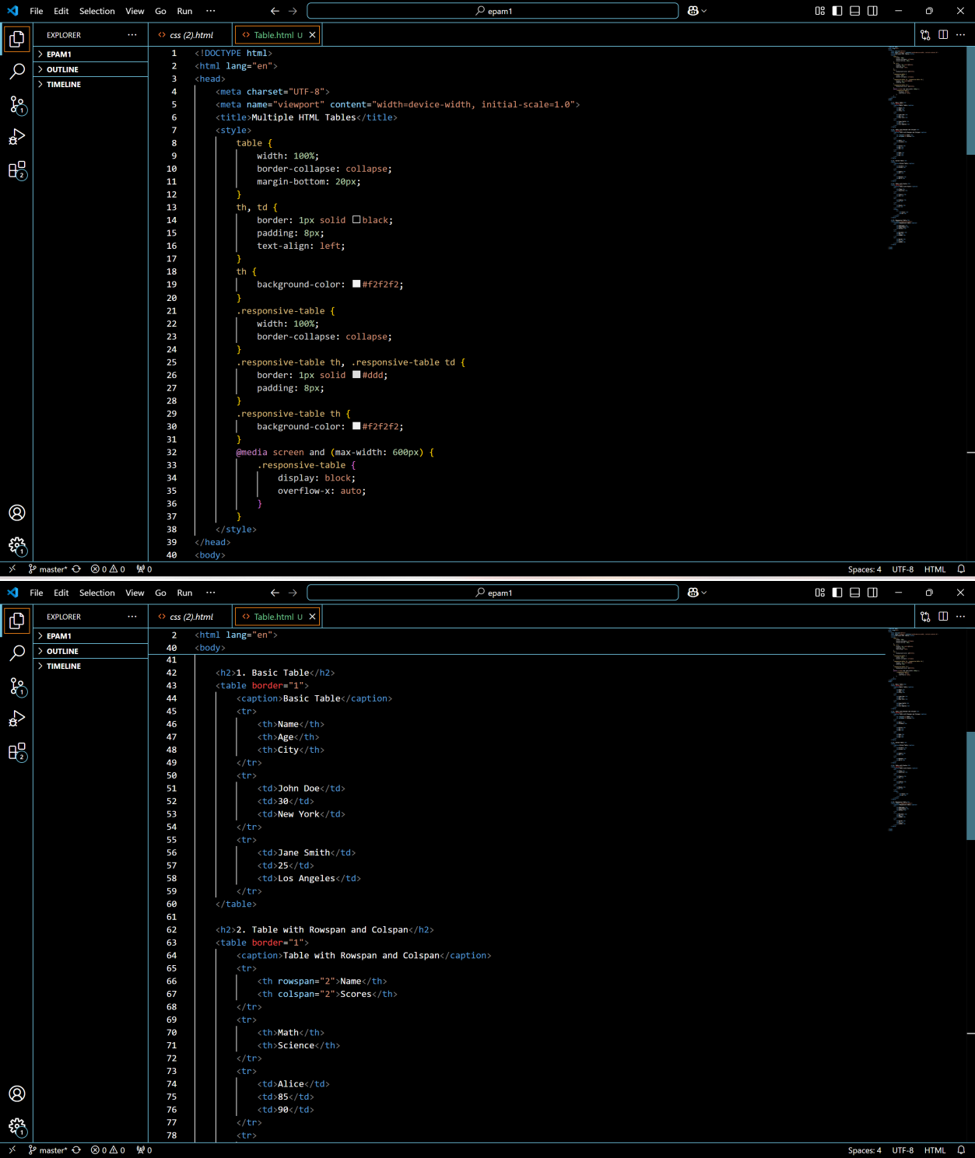

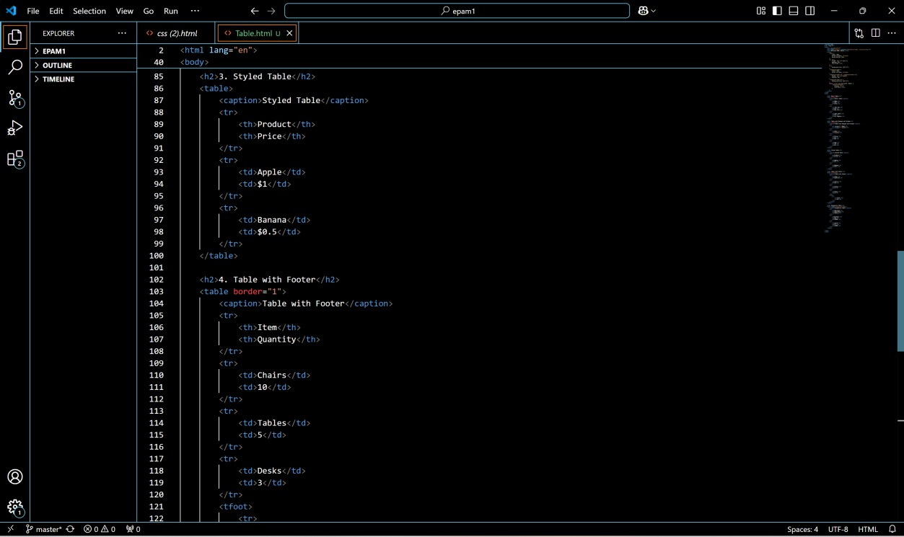

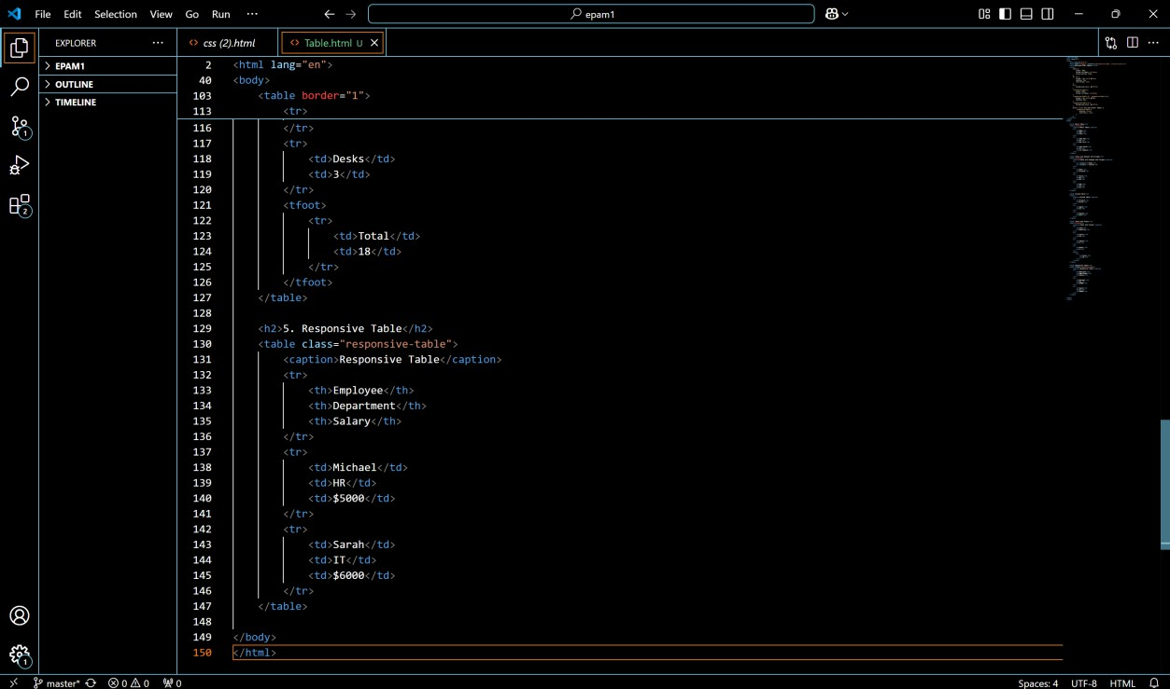

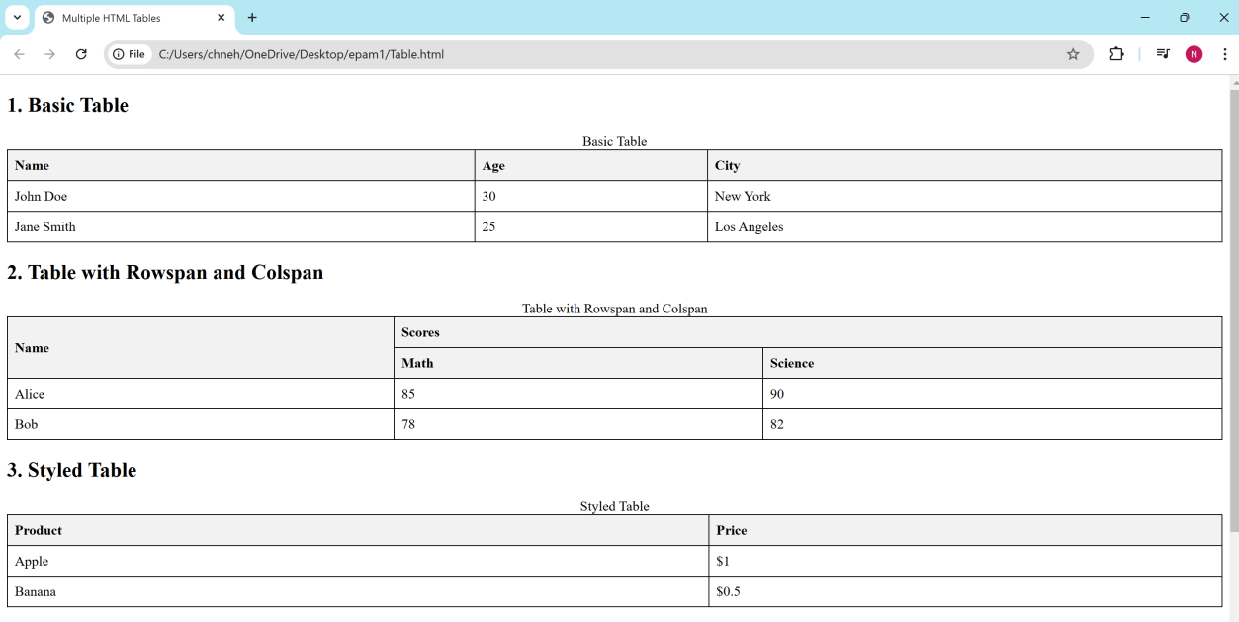

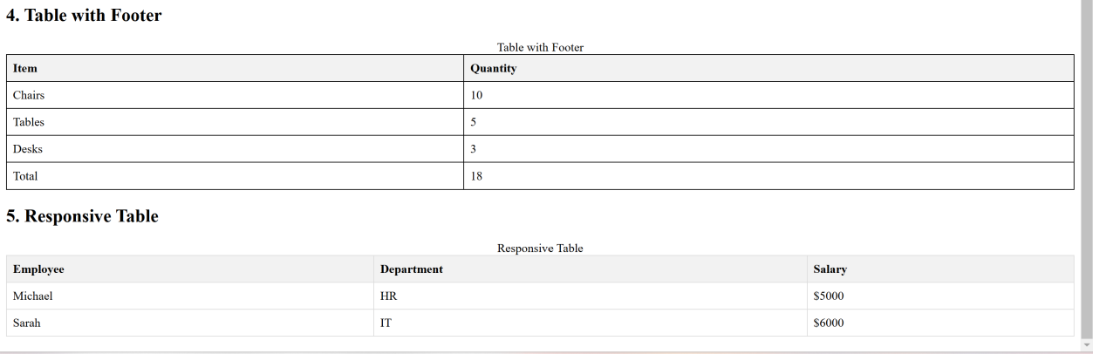

1. Generate login form registration form by applying page validations student and employee (DOB)

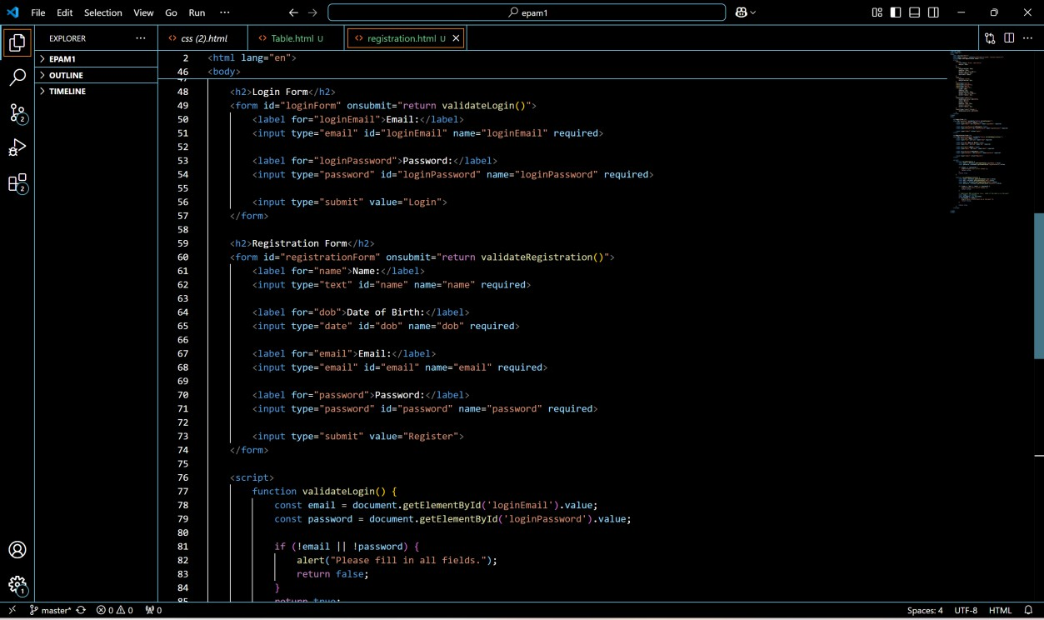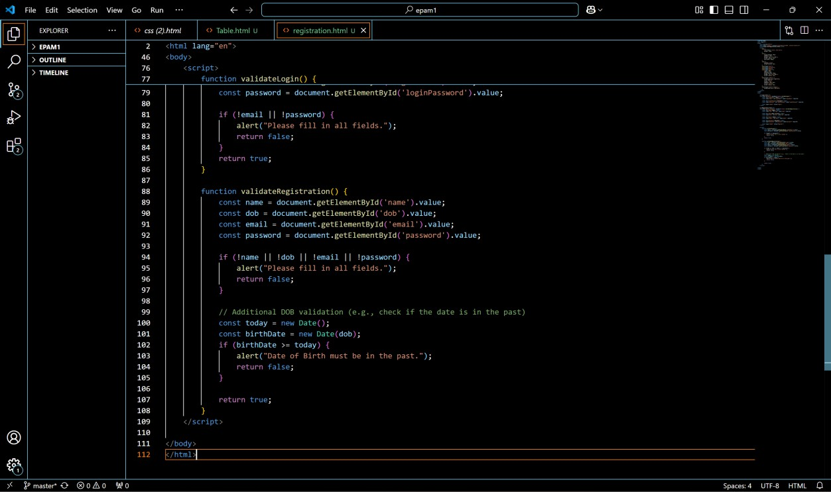

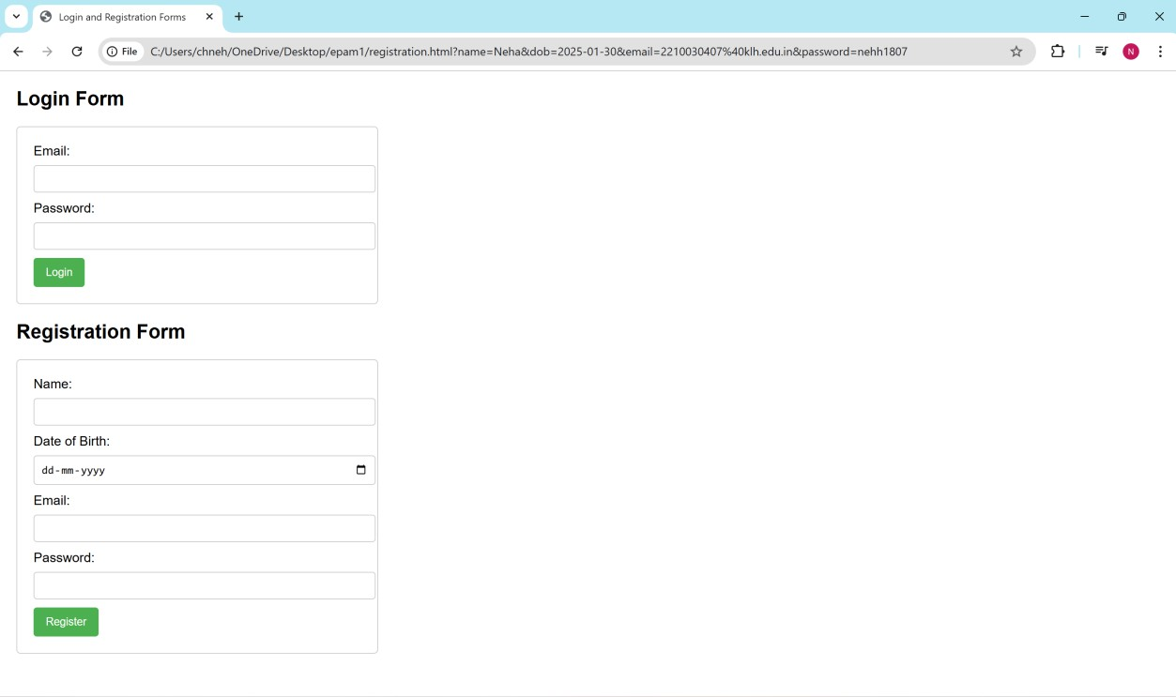

1. DEMONSTRATE A HTML PROGRAM TO DISPLAY ATLEAST 3articles with paragraphs images videos and audios.

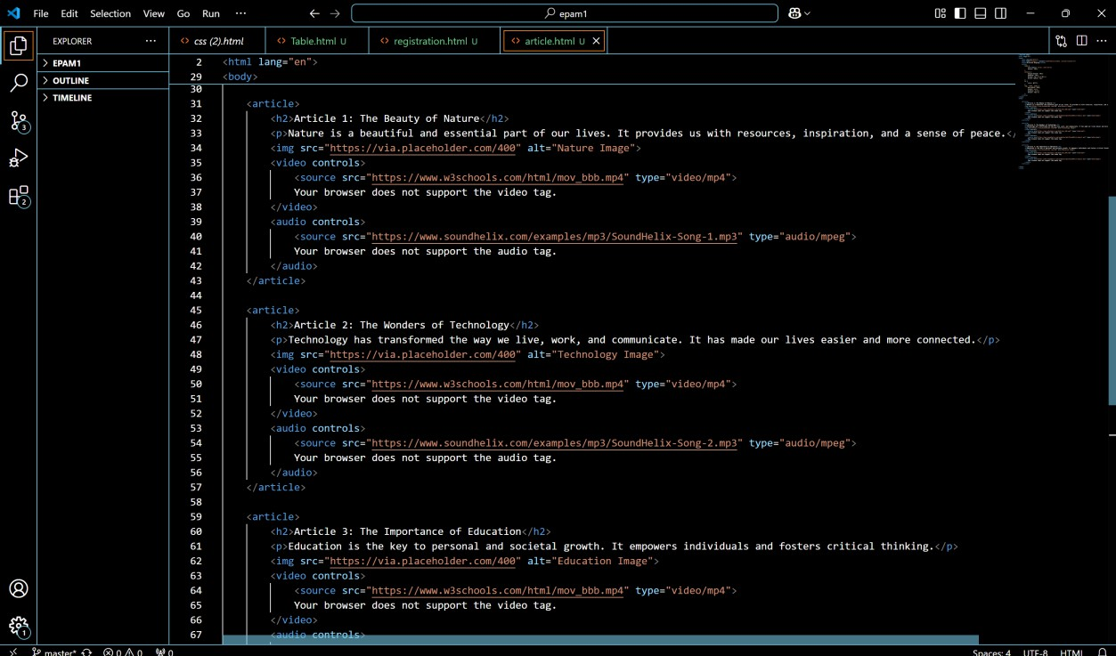

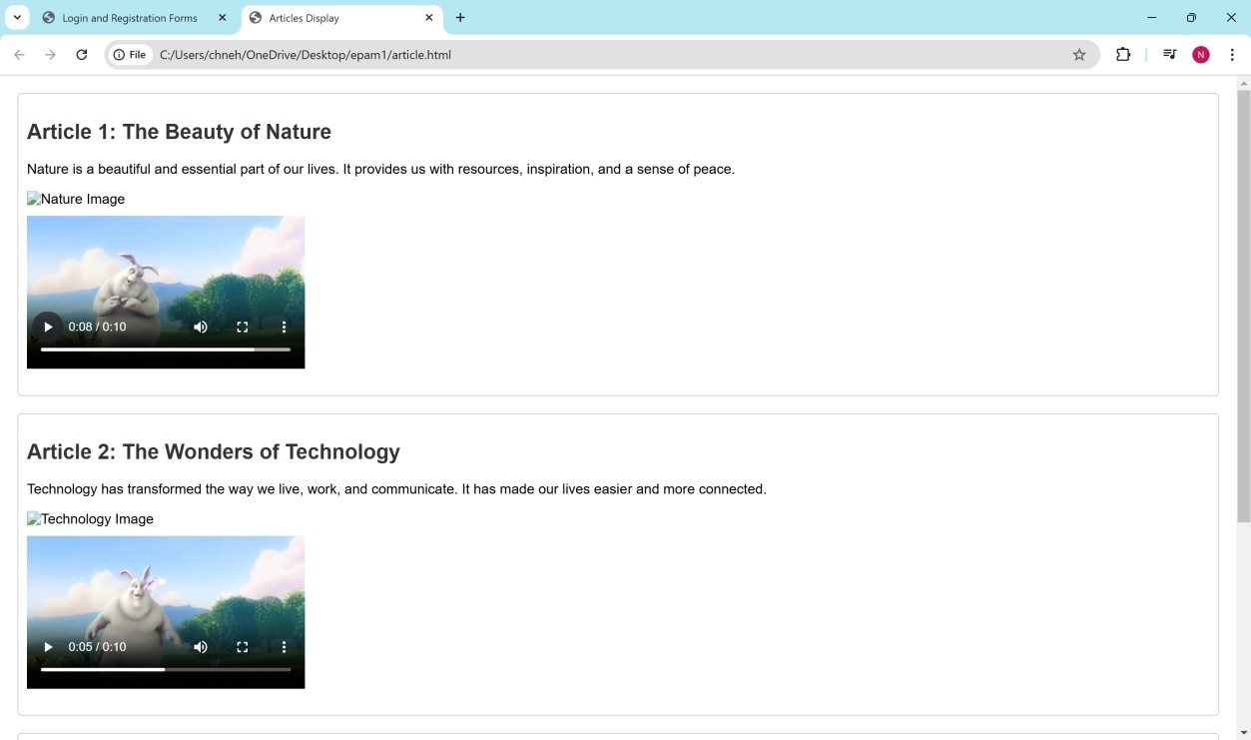

1. DEMONSTRATE A HTML PROGRAM TO DISPLAY section tags in html 5 tags header footer menu.

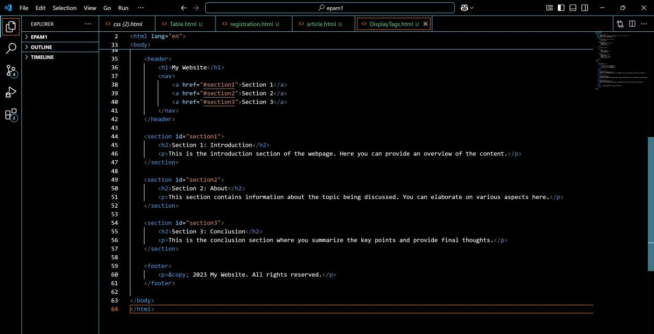

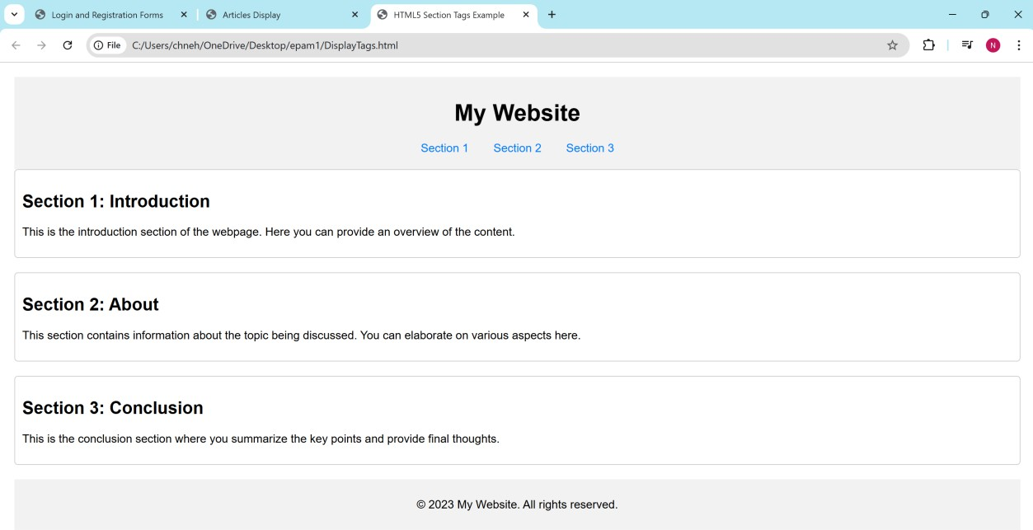

1. DEMONSTRATE A HTML PROGRAM TO DISPLAY iframes 10 where each row should have 10 frames background colour image and position.

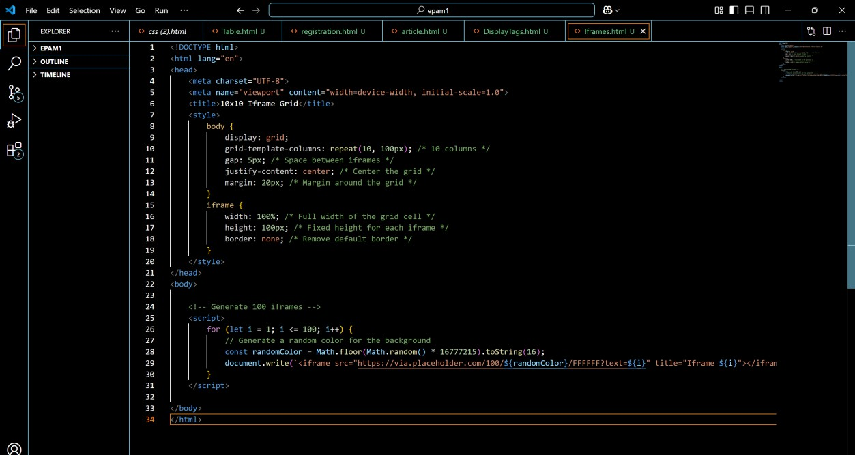

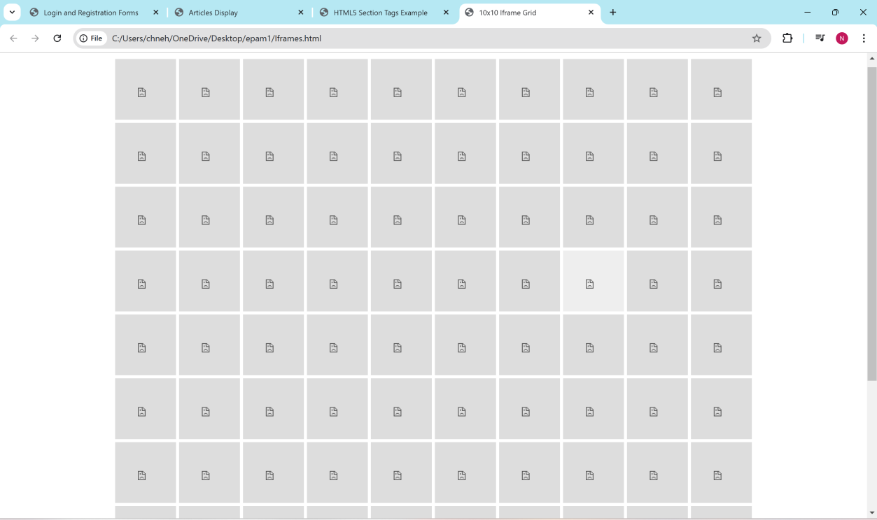

1. DEMONSTRATE A HTML PROGRAM TO DISPLAY #if CGPA is 7.2 to 7.5 display page in red not allowed to placement drive 7.5 to 8.5 display orange maybe placed FOR 10 STUDENTS

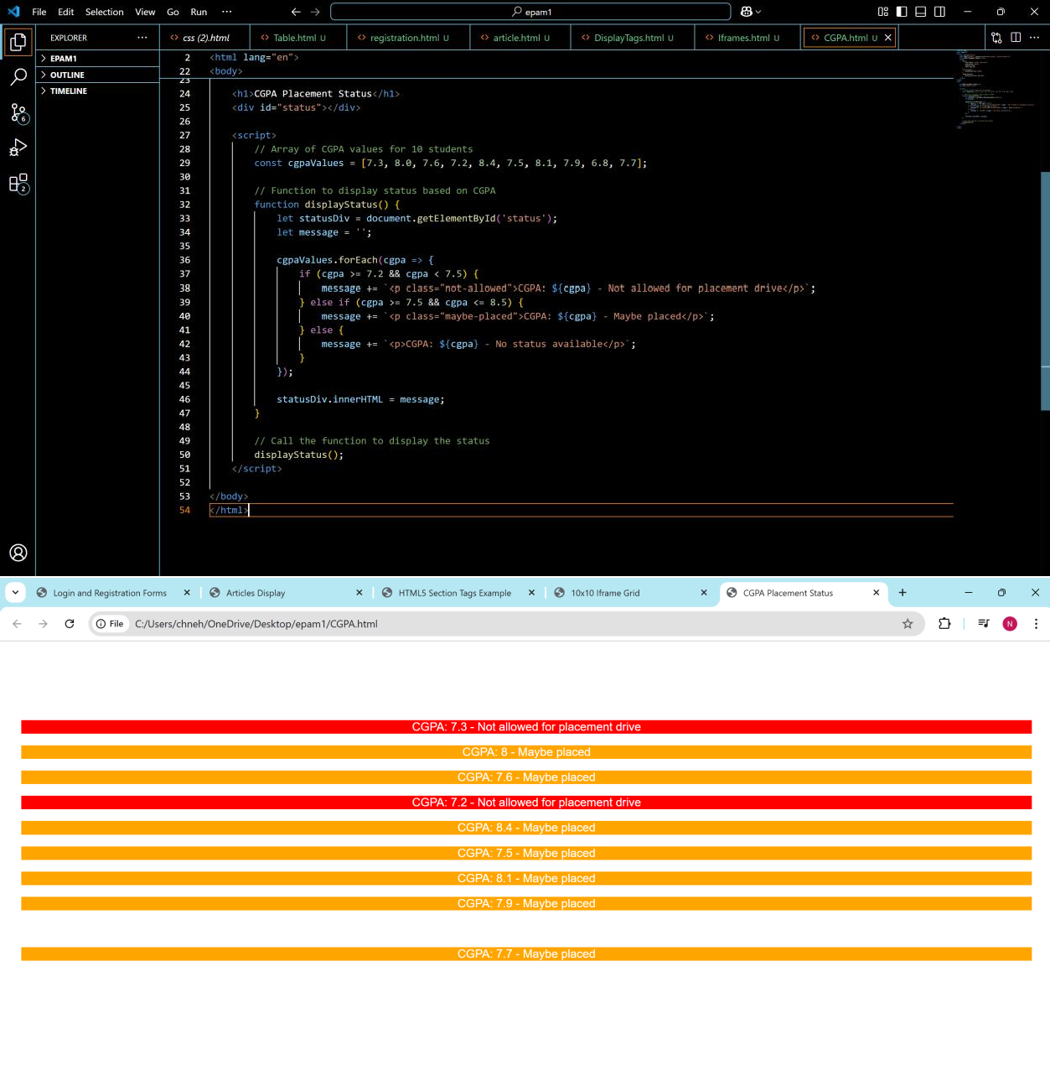

# CO – 2

DEMONSTRATE A HTML PROGRAM TO apply page validation for employee payslip form basic 37,900

; no. of working days = 30; no. of days present/total days; 37900x no.of days; dns 9% of basic; hra hostel= 0.3 room= 0.2 home= 0

